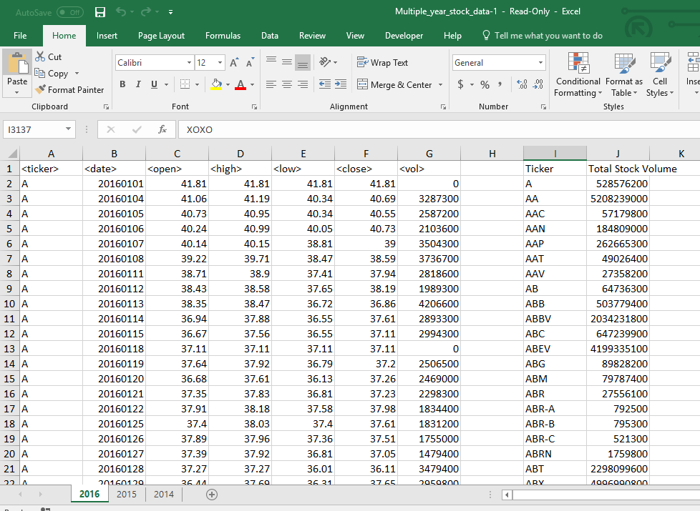

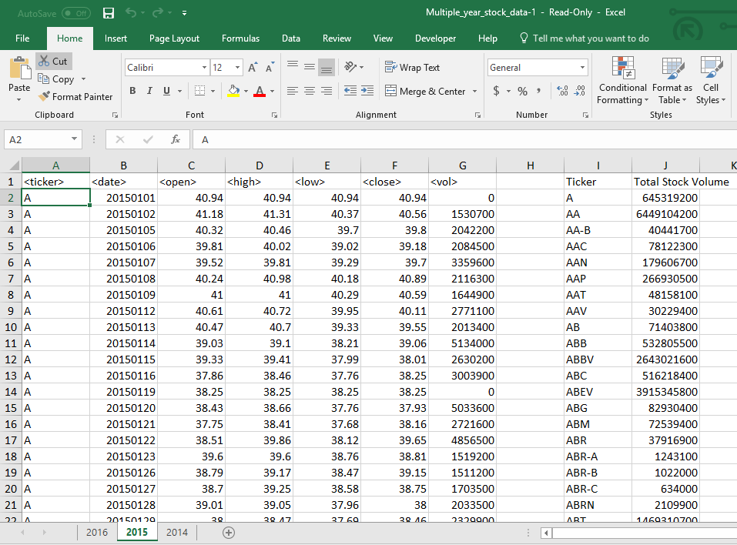

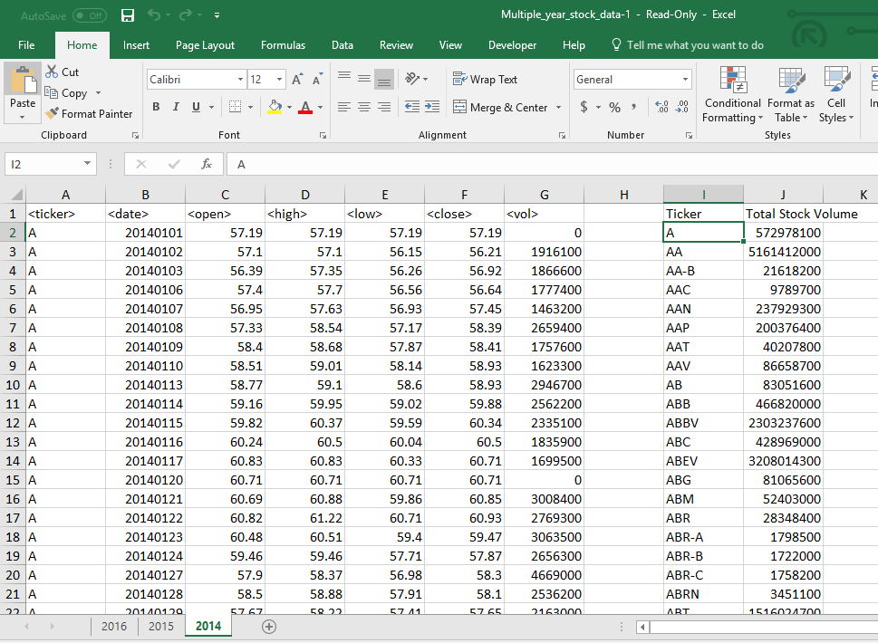

(I couldn’t get the code to run through each tab automatically)

Sub alpha2()

[i1].Value = "Ticker"

[j1].Value = "Total Stock Volume"

Dim ticker_Total As Double

ticker_Total = 0

Dim Summary_Table_Row As Integer

Summary_Table_Row = 2

'Dim ws As Worksheet

'For Each ws In ThisWorkbook.Worksheets

'ws.Activate

For i = 2 To 800000

If Cells(i + 1, 1).Value <> Cells(i, 1).Value Then

ticker = Cells(i, 1).Value

ticker_Total = ticker_Total + Cells(i, 7).Value

Range("i" & Summary_Table_Row).Value = ticker

Range("j" & Summary_Table_Row).Value = ticker_Total

Summary_Table_Row = Summary_Table_Row + 1

ticker_Total = 0

Else

ticker_Total = ticker_Total + Cells(i, 7).Value

End If

Next i

'Next ws

End Sub